IoT Based Safety Gadget for Child Safety

Monitoring & Notification

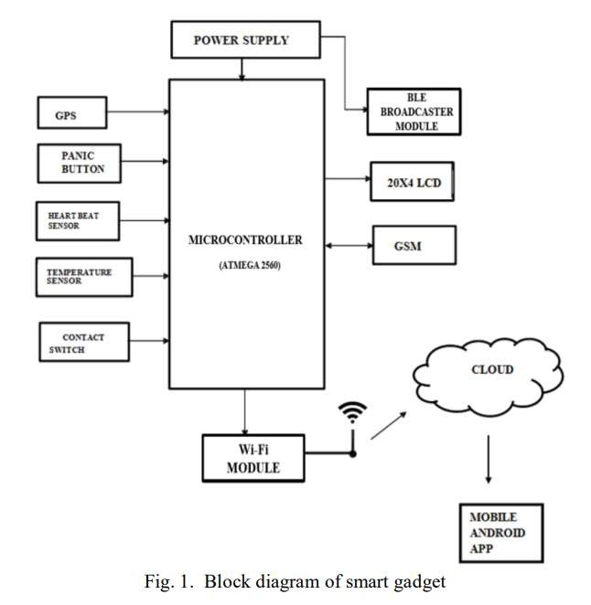SOLUTION ARCHITECTURE:

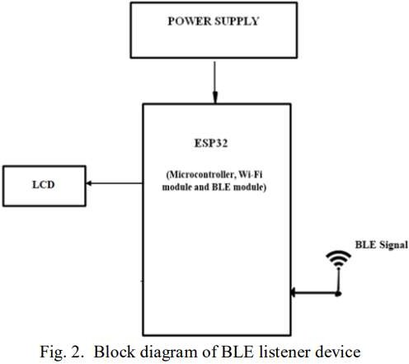

**User Interface**

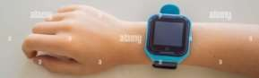

IBM

Cloud

BLE listener

device

Node-

Red

A smart phone with cloud based appliction(Gps system) and support web page.



Parents mobile/web

page

IoT watson

platform

